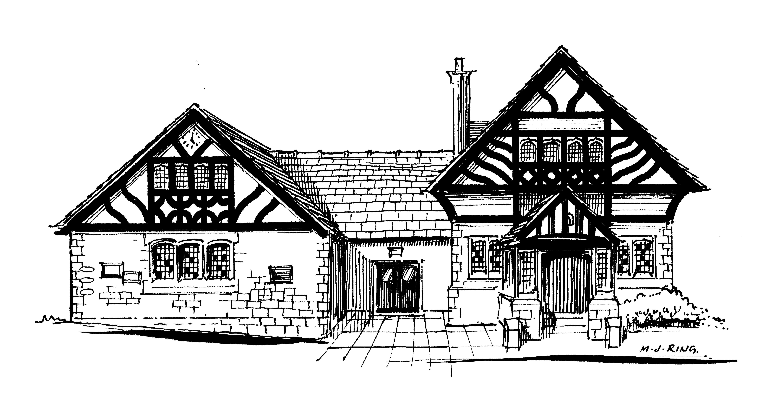

Willaston Memorial Hall

The Green, Neston Road, Willaston, CH64 2XR Charity No 520090
www.willastonmemorialhall.co.uk Email Bookings.MemorialHall@gmail.com

COMMITTEE OF TRUSTEES

Elected
Vacancy (Chair)
Vacancy (Vice Chairman)
Doreen Francey (Secretary)
Keith Greenfield (Treasurer) 0151 364 6942

Representatives
Robert King Willaston Residents and Countryside Society
Sheena Chalmers Willaston Girlguiding units
Val Fisher Willastonhey W.I.
Pam Irving Darby & Joan
Jackie Jenkins Country Market
Liz Young Horticultural Society
None Willaston Pre-School Playgroup (S4YC)
None Hadlow Green Singers

Co-opted
Councillor Myles Hogg 0151 327 4096
Keith Butcher (filling temporary vacancy; stands for election at the next AGM)

Contact numbers are available upon reasonable request.
Keyholders are also available upon reasonable request.

