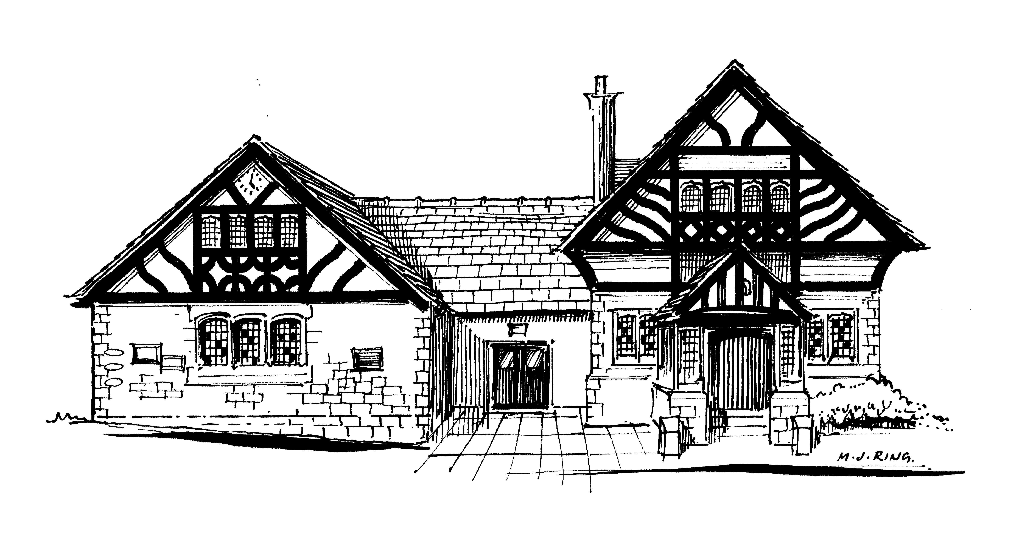

Willaston Memorial Hall

The Green, Neston Road, Willaston, CH64 2XR Charity No 520090

Website: www.willastonmemorialhall.co.uk
Email: Bookings.MemorialHall@gmail.com

COMMITTEE OF TRUSTEES

Elected
Catherine Jones (Chair) 0151 327 1850
Vacancy (Vice Chairman)
Doreen Francey (Secretary)
Lisa Nicholls (Treasurer)

Representatives
Brian Greenhalgh Willaston Residents and Countryside Society
Sheena Chalmers Willaston Girlguiding units
Val Fisher Willastonhey W.I.
Vacant Darby and Joan
Jackie Jenkins Country Market
Vacant Horticultural Society
Suzanne Mills Hadlow Green Singers
Vacant S4YC
Vacant Willaston Badminton Society
Chris Hampshire Friends of Hadlow Road Station

Co-opted
Councillor Myles Hogg 0151 327 4096
Jane Murray (Bookings Secretary) 07535 363988

Contact numbers for trustees and keyholders are available upon reasonable request.

