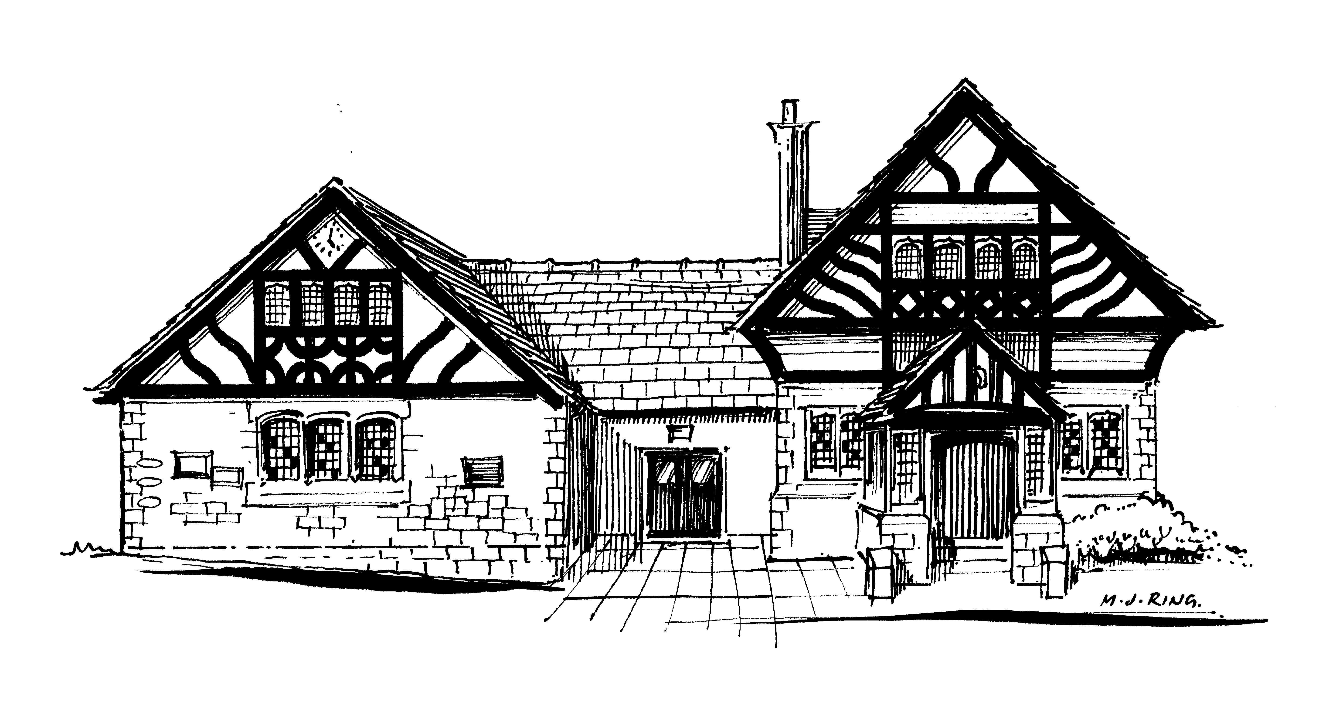

Willaston Memorial Hall

(Registered charity no 520090)

IMPORTANT NOTICE

We request that users of the Hall do not park vehicles along the access road leading to Pollard’s Inn as it can block access for residents of properties close to the Hall. There is an alternative car park in Buckley Lane behind the Hall, accessed via Hadlow Road, with a pedestrian path through to the Hall.

Committee of Trustees
Willaston Memorial Hall

